**EDUCATIONAL INITIATIVES**

**Exercise 1 problems**

**Github link:** <https://github.com/Yoga-naga/Education_Initatives_exercise.git>

**Exercise 1: Problem Statement on Design patterns**

Come up creatively with six different use cases to demonstrate your understanding of thefollowing software design patterns by coding the same.

1.Two use cases to demonstrate two behavioural design pattern.

2.Two use cases to demonstrate two creational design pattern.

3.Two use cases to demonstrate two structural design pattern.

**OUTPUT:**

1. Behavioural design

1.Observer

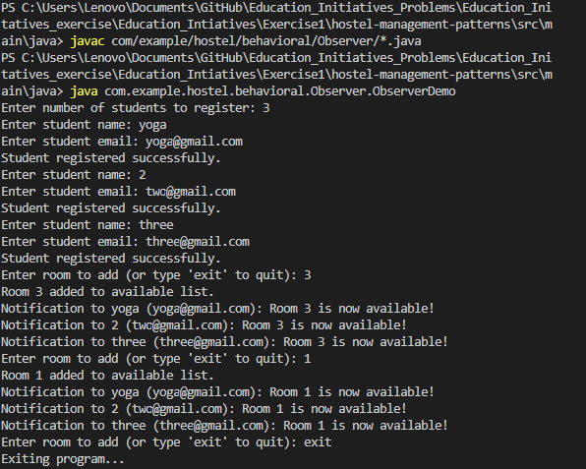

2.Strategy:

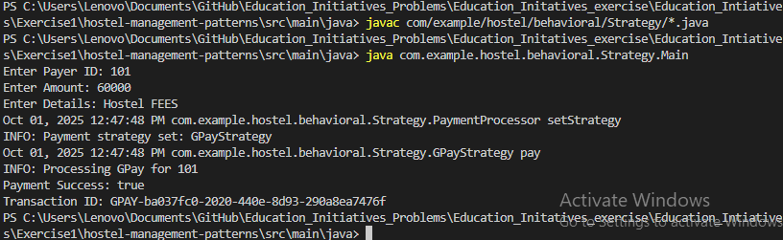

1. creational design
2. Factory

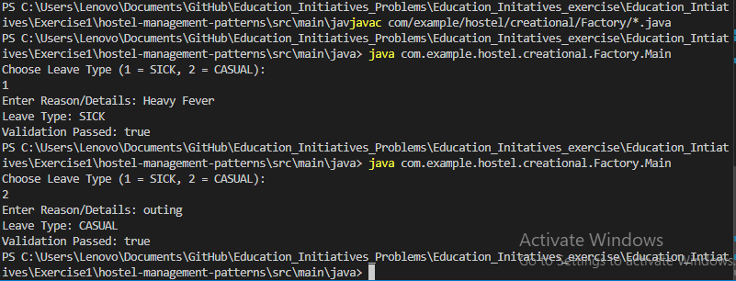

2. Builder

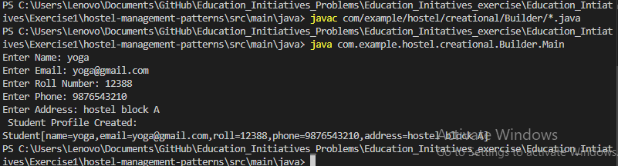

1. structural design
2. Adapter

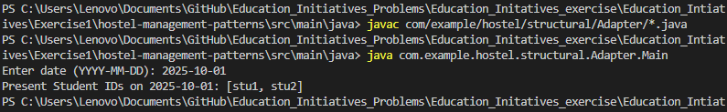

1. Decorator

